[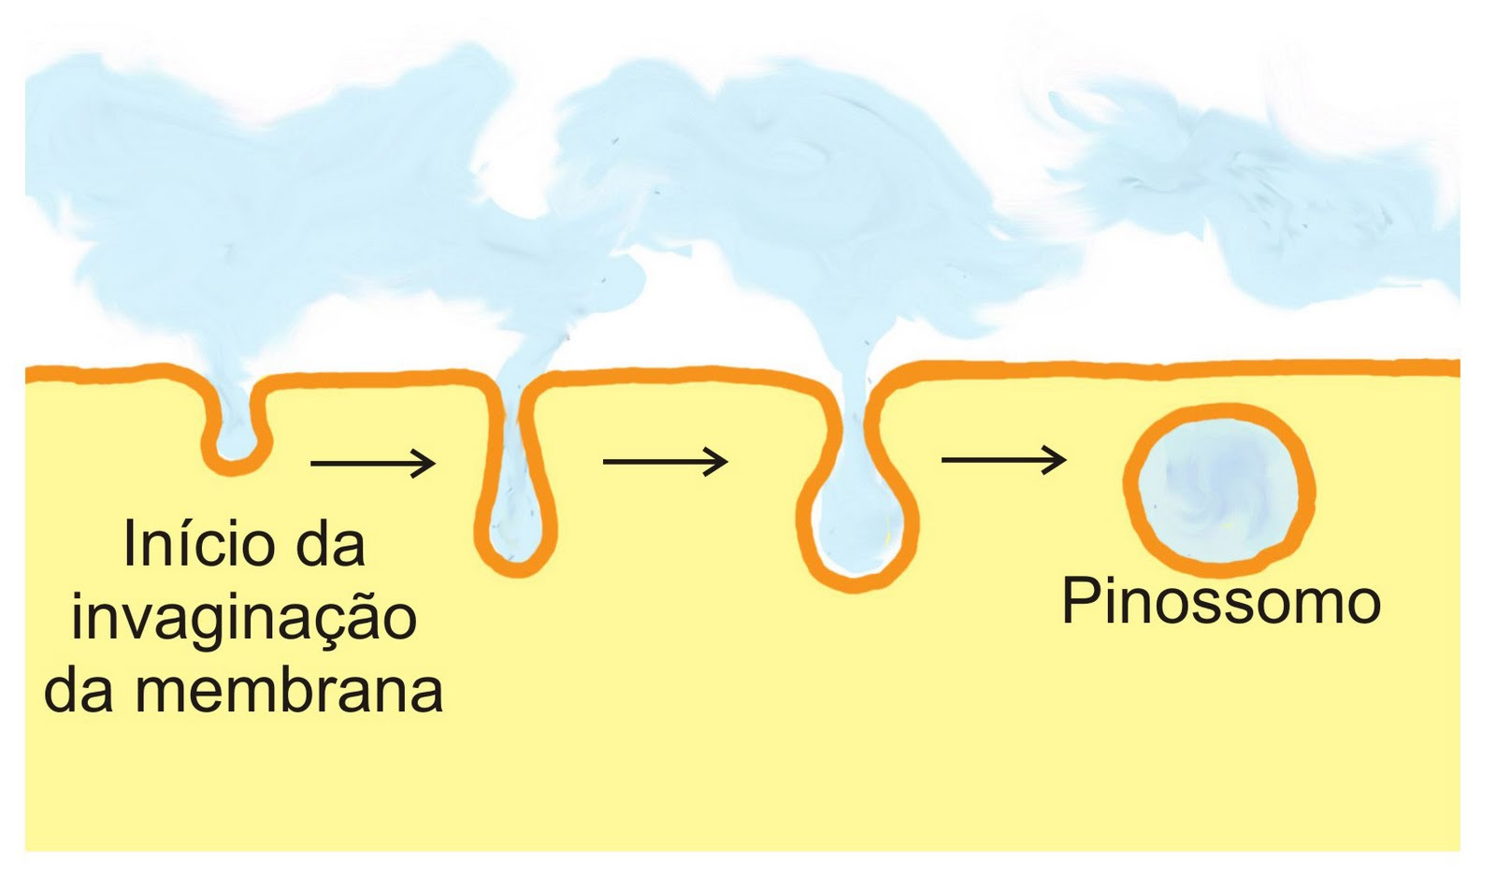](http://www.google.com.br/url?sa=i&rct=j&q=pinocitose&source=images&cd=&cad=rja&docid=HRNk0AleaBoZhM&tbnid=rF0lx1Wvu8hm_M:&ved=0CAUQjRw&url=http%3A%2F%2Fprofessorthiagorenno.blogspot.com%2F2011%2F07%2Fcitologia-004-fagocitose-e-pinocitose.html&ei=nRsuUbfaF4PM9gTNy4DQCQ&bvm=bv.42965579,d.eWU&psig=AFQjCNET3qY1dXwqHchV68oxRyqhbItGBA&ust=1362062568589138)[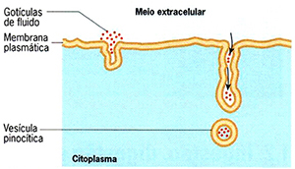](http://www.google.com.br/url?sa=i&rct=j&q=pinocitose&source=images&cd=&cad=rja&docid=OT5l8FzdwmPDcM&tbnid=xa7CQRYA-Qvp5M:&ved=0CAUQjRw&url=http%3A%2F%2Fwww.infoescola.com%2Fcitologia%2Fendocitose%2F&ei=cBsuUYHAN4HA9QTb34GoAw&bvm=bv.42965579,d.eWU&psig=AFQjCNET3qY1dXwqHchV68oxRyqhbItGBA&ust=1362062568589138)